# VISVESVARAYA TECHNOLOGICAL UNIVERSITY

## BELAGAVI - 590008

**A PROJECT ON,**

# “PLANT LEAF DISEASE DETECTION USING MACHINE LEARNING”

### By

**Bhakti Chandilkar USN: 2JR18CS011**

**Praveen Ukkoji USN: 2JR18CS051**

**Shivani Shirguppi USN: 2JR18CS068**

**Vishal Barale USN: 2JR19CS437**

*Under the guidance of*

**Prof. Sapna Yakkundi**

Assistant Professor

Department of Computer Science & Engineering.

*Submitted to the*

**DEPARTMENT OF COMPUTER SCIENCE & ENGINEERING**



**JAIN COLLEGE OF ENGINEERING AND RESEARCH**

**Approved By AICTE, New Delhi. Affiliated to VTU, Belgaum. Recognised by Govt. of Karnataka**

### Udyambag, Belagavi – 590008 2021-2022

**ABSTRACT**

The detection of plant leaf is very important factor to prevent serious outbreak. Automatic detection of plant disease is essential research topic. Most plant diseases are caused by fungi, bacteria, and viruses. Fungi are identified primarily from their morphology, with emphasis placed on their reproductive structures. Bacteria are considered more primitive than fungi and generally have simpler life cycles. With few exceptions, bacteria exist as single cells and increase in numbers by dividing into two cells during a process called binary fission. Viruses are extremely tiny particles consisting of protein and genetic material with no associated protein. The term disease is usually used only for the destruction of live plants. The proposed processing scheme uses machine learning and dynamic plants image model to predict disease related to the leaf. Using machine learning makes platform generic and useful. Adding and updating new diseases and datasets is easy if machine learning is use. Using cloud computing for storing retrieving and serving data from machine learning model is efficient choice and both technologies can be used to create system.

# LITERATURE REVIEW

After studying the journal paper, we came across different researches used for plant leaf disease detection. Each methodology has its own benefits. Major techniques are briefed in following section.

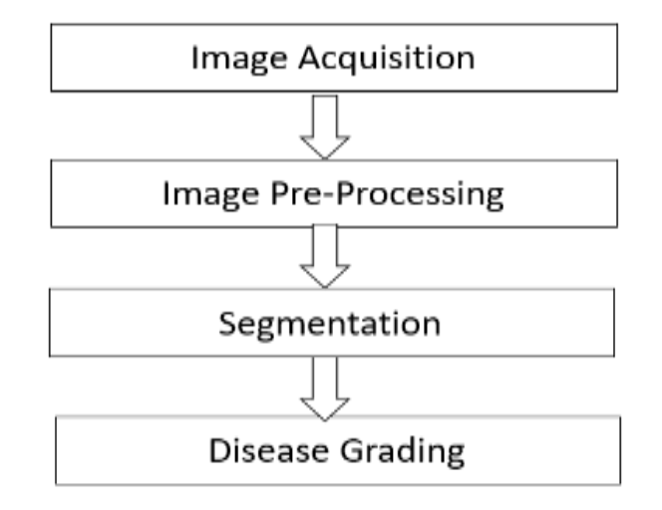

**Image Acquisition**: First stage of any vision system is the image acquisition stage. The digitization and storage of an image is referred as the image acquisition. After the image has been obtained, various methods of processing can be applied to the image to perform the many different vision tasks required today. However, if the image has not been acquired satisfactorily then the intended tasks may not be achievable, even with the aid of some form of image enhancement.

**Pre-processing images**: commonly involves removing low frequency background noise, normalizing the intensity of the individual particles images, removing reflections, and masking portions of images. Image pre- processing is the technique of enhancing data images prior to computational processing.

**Image Segmentation**: Image segmentation refers to the process of partitioning the digital image into its constituent regions or objects so as to change the representation of the image into something that is more meaningful and easier to analyze. The level to which the partitioning is carried depends on the problem being solved i.e. segmentation should stop when the objects of interest in an application have been isolated.

This model has good accuracy but is not generic approach to solve problem as different algorithm will be used to solve different problems. In real world where information is processed.

**PROPOSED METHODOLOGY**

Supervised learning is the machine learning task of inferring a function from labeled training data. The training data consist of a set of training examples. In supervised learning, each example is a pair consisting of an input object (typically a vector) and a desired output value (also called the supervisory signal). A supervised learning algorithm analyzes the training data and produces an inferred function, which can be used for mapping new examples. An optimal scenario will allow for the algorithm to correctly determine the class labels for unseen instances. This requires the learning algorithm to generalize from the training data to unseen situations in a "reasonable" way. In Our case unseen situations are images of plants unidentified by the model.

we present a mathematical model for kNN algorithm For a given query instance xt , kNN algorithm works as follows:

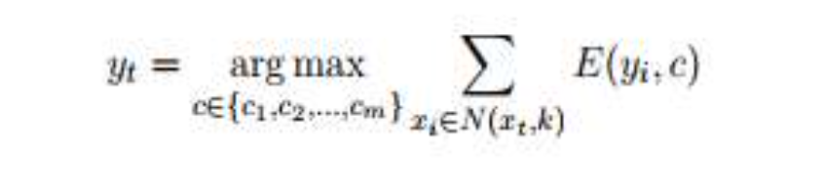

Where yt is the predicted class for the query instance xt and m is the number of classes present in the data. Also N(x,k) =Set of k nearest neighbours, Where p(cj ) (xt,k) is the probability of occurrence of jth class in the neighborhood of xt . Hence Equation becomes,

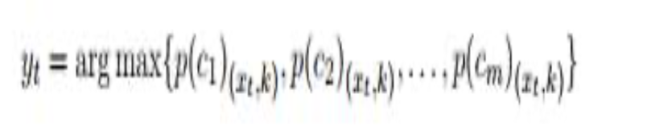

**REFERENCES**

[1]. M. Armbrust, A. Fox, R. Griffith, A. D. Joseph, R. Katz, A. Konwinski, G. Lee, D. Patterson, A. Rabkin, I. Stoica, et al. Detection of unhealthy region of plant leaves using image processing and genetic algorithm VijaiSingh , Varsha.

[2]. Zhiping Peng1, Delong Cui1*, Jianbin Xiong1, Bo Xu1, Yuanjia Ma1, Weiwei Lin2

A framework for detection and classification of plant leaf and stem diseases Malik SuliemanBani-Ahmad.